**Tammer “The Hammer” The Heart Beacon**

April 2nd, 2018: Enroute to pick up my wife Tammy Sue Lee (whom I call “Tammer the Hammer”) soup from Panera Bread, a **HammerTime** Construction panel truck turned off route 35 north onto Shrewsbury Avenue

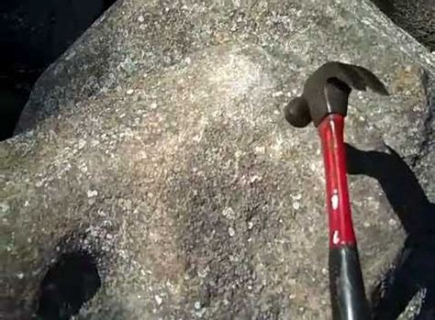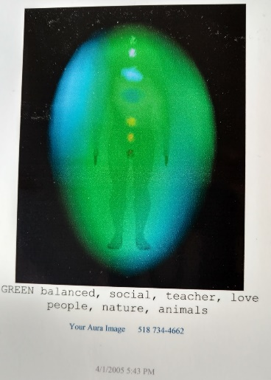

Hammering the Ringing Rocks in Bucks County Pennsyvania

Hammertime Construction Inc. Directions Address: 35 ***Ice Pond Rd****,* Levittown, PA 19057 Phone: (215) 945–1001

A few nights ago, Tammy told me her dream about us being at Ringing Rocks Park near Pottstown PA north of Washington’s Crossing LINK

What is Tammer The Hammer The Heart Beacon sounding the alarm or ringing the bell for? Global economic collapse / Epic climate change?

Back tracking, on March 30th, 2018 I pressed the garage door button on the left side of the garage – which coincidentally, corresponds to the lung that had too much scarring by cancer to seal using the Pleurodesis procedure that seals the membrane surrounding the lungs with a (talcum) powder. The garage door’s manual release cord caught on the roof rack of my Tahoe Truck, sprung backwards and wrapped around the metal bar (spine) of the garage door’s center bar. Reverend Kathy Graves, the Shaman Circle of the Sacred Earth that I had seen for counseling, energy balancing sessions said that if you asked Spirit a question, you will get an answer.

the garage door incident where I backed into the garage door unaware that it had not be raised to it’s full height represented the cancer lesions inside the spinal column in the L4 region below the gap between the spine and the cerebellum and the motor center. This could spark a long discussion of what the Yogi’s of India have known for millennia, what is perhaps a high level lesson, “secret” known to Free Masons that relates to Capricorn / Goat of Mendez. It’s a lesson that I have become aware of late in life. It is a core lesson to those who might listen to Gnostic, Gnosis recordings while taking their daily walks listening to podcasts. Listened to, heard but not heeded.

When Tammy and I spoon in bed, she places my hand at the exact place where Tammy’s breast cancer was initially detected. She received a procedure and was pronounced clear of cancer. Linda the Psychic’s comment on there would be health issues but they would be taken care of was completed in my mind when Tammy had her gall bladder removed.

## [Spiritual](http://www.insightstate.com/health/suicide-spiritual-meaning-causes-signs-statistics/)[Meaning](http://www.insightstate.com/health/nephritis-pyelonephritis-spiritual-meaning-causes-symptoms-prevention/) **of Gallbladder Problems**

Bile is an extremely aggressive substance that burns fat. Gallbladder problems are always related to aggression, and it is obvious that you are not fully aware of being aggressive and indifferent, therefore, you are not releasing it.

This type of symptoms usually indicates a suppressed aggression and a blockage of energy. The typical choleric person is bilious by nature because she doesn’t release energy consciously. Take a conscious look at anything that makes you angry without judging yourself. Anger will dissolve, and you will be able to use energy in a positive way. [LINK](http://www.insightstate.com/health/gallbladder-problems-gallstones-spiritual-meaning-causes-symptoms-prevention/)

A close up of a logo

Description generated with very high confidence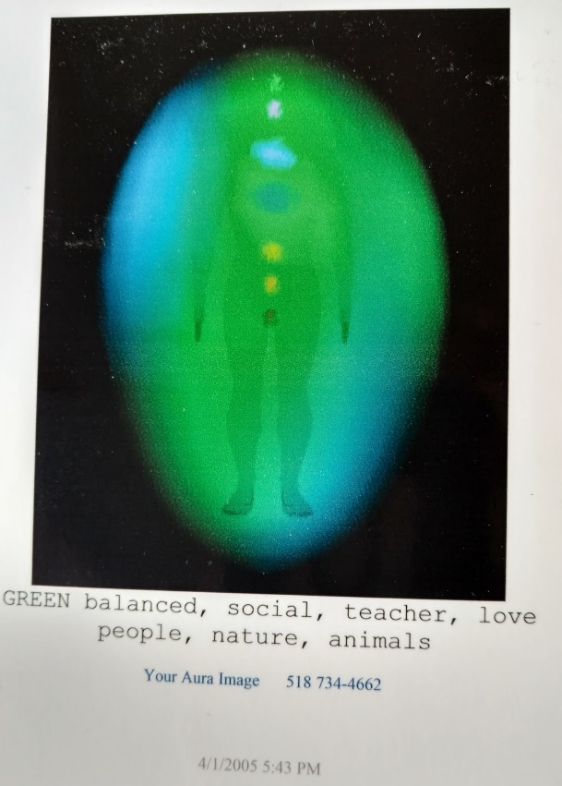

Kundalini Serpent [LINK](http://edgeba.webs.com/thekundaliniserpent.htm)

**The Cynical Idealist A Spiritual Biography Of John Lennon** [**LINK**](http://www.awaken.com/2013/10/the-cynical-idealist-a-spiritual-biography-of-john-lennon/)

A screenshot of a cell phone screen with text

Description generated with high confidence

Lucid Dream of a Golden Dragon chasing a whale under glass bottom boat

I posted and reposted this representation of my dream on Facebook and elsewhere many times over the years always focusing on a business related topic instead of perhaps a medical topic. I had another lucid dream where I dreamt that I was standing on the floor of an ocean and I heard the number 250 repeated twice. This dream was so vivid that when a man walked up to me at a telecommunications conference in Hoboken I attended years ago and asked me how much would I sell the patent Tammy and I filed, I responded “500,000 million” because I had a dream about the number 250.

A zebra standing in a grassy area with trees in the background

Description generated with high confidence

Turtle / Cape Hatteras Light House along my walking route

Tammy’ mother Kathy told Tammy that when she was born, Tammy looked like a turtle to her. Coincidentally, I walk past this arrangement walking

On April 13th, 2018 we took a trip to Seven President’s Beach, Long Branch New Jersey. A man who was fishing told us to look out at 2 o’clock to see a whale headed south. I looked and finally saw the whale’s spouting. On 13 April 2013, I paid her funeral bill of $4,777.00 dollars. Her remains were cremated in Libertyville New Jersey to be placed in a urn made of salt then cast into the winds in an undisclosed, top secret location.

A group of people posing for the camera

Description generated with very high confidence

Boardwalk near Seven President’s Beach, Long Branch NJ where we often walked

Reverend Kathy Graves, Shaman Circle of the Sacred Earth saw Tammy Lee and I both together in front of the right paw of the Sphinx in Giza.

A rocky cliff

Description generated with high confidence

I enjoy listening to Graham Hancock, Randall Carlson describing how the ancient megalithic monuments describe cyclic patterns of catastrophe.

A sign in front of a building

Description generated with very high confidence

Tonight at 10:13, my wife who has been given the stage four cancer talk twice and is at home in hospice care said again “I’m tired” (of everything). My take on this is that Tammy will depart this world soon and fly like a kite up to go **home** (she asked for a Wendy’s ***home*** style chicken sandwich this weekend) above this low, slow, resonance, frequency and vibration (nod to Tesla and Einstein) and often mean spirited plane of existence prior to the pending [“RESET”](https://medium.com/@heart.beacon.cycle/time-for-a-universal-event-bus-8fd12b5481b1) of the economy / population before the impending massive climate change due to the earth’s farthest position from the sun in 100,000 years known as the [Milankovitch](https://youtu.be/6lbJrvtxWNE) Cycles and Ice Age <https://youtu.be/anZJZCvGoZE> [Link](https://youtu.be/anZJZCvGoZE)

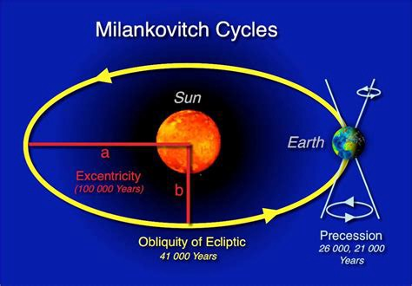

Milankovitch Cycle

Earth’s orbit approximates an [ellipse](https://en.wikipedia.org/wiki/Ellipse). [Eccentricity](https://en.wikipedia.org/wiki/Eccentricity_%28orbit%29) measures the departure of this ellipse from circularity. The shape of the Earth’s orbit varies between nearly circular (with the lowest eccentricity of 0.000055) and mildly elliptical (highest eccentricity of 0.0679)[[3]](https://en.wikipedia.org/wiki/Milankovitch_cycles#cite_note-3) Its geometric or logarithmic mean is 0.0019. The major component of these variations occurs with a period of 413,000 years (eccentricity variation of ±0.012). Other components have 95,000-year and 125,000-year cycles (with a beat period of 400,000 years). They loosely combine into a 100,000-year cycle (variation of −0.03 to +0.02). The present eccentricity is 0.017 and decreasing.

Effect on temperature: The semi-major axis is a constant. Therefore, when Earth’s orbit becomes more eccentric, the [semi-minor axis](https://en.wikipedia.org/wiki/Semi-minor_axis) shortens. This increases the magnitude of seasonal changes.[[4]](https://en.wikipedia.org/wiki/Milankovitch_cycles#cite_note-4)

<https://en.wikipedia.org/wiki/Milankovitch_cycles>

See prior posts: dog sleds headed towards poles, Casper, Caspian Sea, Stay Puff Marshmallow Man & RESET in the 2nd video:  
 <https://youtu.be/anZJZCvGoZE> Link Milankovitch Cycles Ice Age  
 [https://youtu.be/DboD8zK3Fvo](https://l.facebook.com/l.php?u=https%3A%2F%2Fyoutu.be%2FDboD8zK3Fvo&h=ATOyss4DwY8LQnCu2zbuvXyN9Xh1C0knLDZ0_8uFV8GOQLKbZ5fhnwAIDYFQSfngTHNZZrcJtYtg4HlO-XY55_nUBu9QXCqaaBkvqJo_-WdkAUyr02rBgJqJCAGkGd6GNHn2A67ba-6RhX0n71yHL4A9) LINK

[**Dog sleds, poles, Casper — Caspian Sea caves — Stay Puff Marshmallow Man / RESET** *see prior posts from Shaman Circle of the Sacred Earth Reiki energy balancing / counseling sessions: dog sleds headed…*medium.com](https://medium.com/@heart.beacon.cycle/dog-sleds-poles-casper-caspian-sea-caves-stay-puff-marshmallow-man-reset-80856929f011)

— — — — — — — — — — — — — — — — — — — — — — — — — — — —

**Sun's 11 year HEARTBEAT / Mini Ice Age Royal Astronomical Society (RAS) Science News: Solar activity predicted to fall 60% in 2030s to 'mini ice age' levels:**

**A picture containing indoor

Description generated with very high confidenceA picture containing sky, outdoor

Description generated with very high confidence**

**Sun driven by double dynamo** **Date: July 9, 2015:**  **A new model of the Sun's solar cycle is producing unprecedentedly accurate predictions of irregularities within the Sun's 11-year heartbeat. The model draws on dynamo effects in two layers of the Sun, one close to the surface and one deep within its convection zone. Predictions model predictions suggest that solar activity will fall by 60 per cent during the 2030s to conditions last seen during the 'mini ice age' that began in 1645. Tammy’s Sun sign is Leo ruled by the sun. I was born in the "Weather Capital of the World" coincidentally...**

[**LINK**](LINK)**:** [**https://sciencedaily.com/releases/2015/07/150709092955.htm**](https://sciencedaily.com/releases/2015/07/150709092955.htm)

Tammy’s favorite saying “abundance is enough for the wise” — she had this saying placed on her checks:

Animal Totem: Shrew

In Hindu mythology, the shrew is the vahana, or divine vehicle of Lord Ganesha. The shrew carries Lord Ganesha wherever he travels. It is said that the shrew represents “worldly desires that is meant to be overcome.” / One day at the beach, a stature of Ganesha washed up in front of Tammy’s Feet… coincidentally….

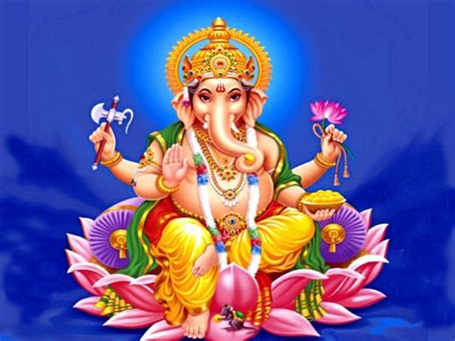

**Animal Symbolism in the Hindu Religion**  
*In Hindu mythology, the shrew is the vahana, or divine vehicle of Lord Ganesha. The shrew carries Lord Ganesha wherever…*

http://www.beliefnet.com

— — — — — — — — — — — — — — — — — — — — — — — — — — — — -

My wife Tammy who has stage IV cancer or “consumption” father was Blackfoot Native American Indian. According to a Shaman, Circle of the Sacred Earth named Reverend Kathy Graves, the energetic force behind the project we have been working on is Great Deer assisted by the Buffalo:

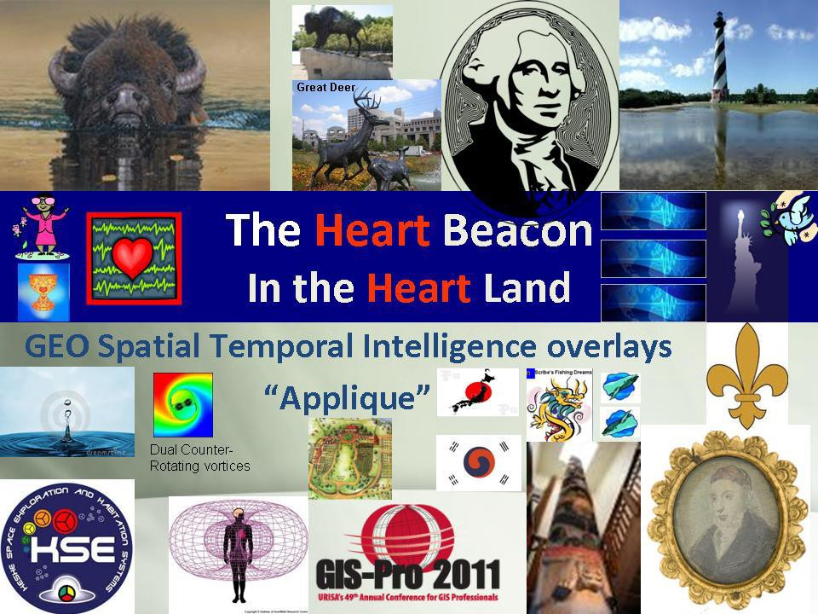

Graphic from presentation In Indianapolis Indiana GIS in the Heartland

**“You are provided for in all ways” – Buffalo Spirit Totem Animal**

The First Nations peoples used / “consumed” all of the Buffalo

[**Buffalo Bison Power Animal Symbol Of Abundance**](http://www.shamanicjourney.com/buffalobison-power-animal-symbol-of-abundance)[**LINK**](http://shamanicjourney.com/buffalobison-power-animal-symbol-of-abundance)

[http://shamanicjourney.com/**buffalobison-power-animal-symbol-of-abundance**](http://www.shamanicjourney.com/buffalobison-power-animal-symbol-of-abundance)

Buffalo/Bison’s medicine includes manifestation, protection, earth creativity, feminine courage, abundance, knowledge, generosity, hospitality, sharing work, courage, strength, challenge, survival, giving for the greater good, formulating beneficial plans. Those with buffalo as power animal must walk a sacred path, honoring every walk of life.

Speaking of consumption, my wife’s stomach has swollen to the point of her looking pregnant coincidentally. Her Sun sign is Leo. Her chart astrological birth chart shows a bowl formation (most aspects located in one location) i the 7th House of relating to others and spouse (as the contaminant).

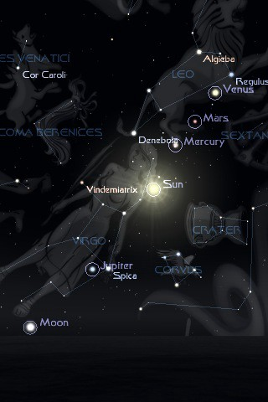

Revelations 12 Leo / Virgo start of 7 year tribulation period 2017–2024 Revelations posts 7 year window 2017–2024 [LINK](https://www.youtube.com/watch?v=O9pPhJ66pIE)

**Rune  
(Equivalent of “Tammy Sue Lee”) see http://facade.com**

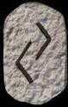

Ger Rune Stone

**Ger** is one of the runes that touches on the cycles of the year, in this case the fall harvest. These cycles are eternal, which is represented in the rune by the fact that it is unchanged by reversal. Ger can represent **pregnancy** or other forms of fruitfulness, and is especially indicative of the cycles of **providence and karma** — that which has been sown is now being reaped. This rune can also represent the cycles of wealth, for crops were frequently a sign of wealth.

Reverend Kathy Graves Shaman of the Sacred Earth clairaudience from one of many Reiki energy balancing / counseling / healing sessions: “Providence”

It never occurred to me that my wife Tammy might pass as her mother did, gasping for breath with her lungs filling up with mucus and fluid because the brain was unable to send signals to the lungs. As of 4:03 AM, the 6th of April, Tammy is in an adjacent room sleeping after giving her some sips of water.

— — — — — — — — — — — — — — — — — — — — — — — — — — — — — -

Speaking of auric field contaminants, using Vedic / Sidereal astrology, I’m a Capricorn on the cusp of Aquarius within orb of this star:

Sinistra The left hand of Serpentarius (Ophiuchus). Immoral, mean and slovenly, depraved, lustful, wanton, infamous, scandalous, addicted to sorcery and poisoning 29° Sag 45 29° Sag 53 Unfortunate Saturn/ Venus ν (Nu) Ophiuchi K0 (orange) Mg.3.32 var.

A close up of a device

Description generated with high confidence

KITE !!!

Tammy’s natal sun (Will, vitality) in the sixth house of nose to the grindstone as a diligent and dedicated worker. The sixth house also involves [medical issues.](https://youtu.be/8DcbdGZUUsw) Linda “The Psychic Shield” said that Tammy would have medical issues. After a long, “**pregnant** pause”, Linda said that her medical issues would be taken care of. The medical issues would have been taken care of had I figured out the Shaman, Circle of the Sacred Earth’s “Energizer Bunny” message citing the need for her / me to alkalize our diets and detox our guts — in my sake to resolve the mood swings associated with poor eating habits and chasing after windmills along with medicating myself with my own endorphins which is a blogpost in itself.

I have at least three reasons to believe this:

Reverend Kathy Graves is a medical intuitive who is a Master Reiki Practitioner. Her symbolism, for example, see the energizer bunny beating a **DRUM** below is clearly about a medical condition because she as a medical intuitive and healer, leads First Nation Indigenous type drumming circles. She believes she was indigenous or First People’s in a prior reincarnation. Energizer Bunny commercial [LINK](https://youtu.be/qiFQsxGUQOI)

After Tammy’s radiation, she was on a “chemo break” because you can’t have radiation and chemo simultaneously if memory serves. We traveled home to my parents home and went out to the Knickerbocker bar where a candle holder of very thick glass suddenly split into two pieces / divided (metastasized) right in front of us. I took a picture of this .. will insert later

Upon returning home from the hospital one night after one of Tammy’s hospitalizations, the Kleenex box downstairs had half of it’s tissues pulverized into very small pieces… they were pulverized — not torn into strips as you would expect if mice were using the material as nests. The flecks of tissue paper were so fine that I vacuumed them up. I did not have the presence of mind to photograph this phenomenon I regret to say.

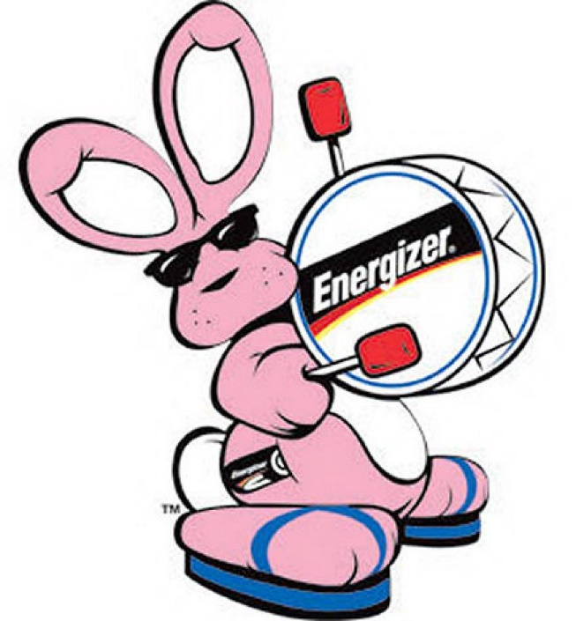

Shaman’s Energizer ALKALINE Battery image heeded too late. We could have / would have / should have detoxified, energized, and alkalized PH

See Charlotte’s Web [post](https://medium.com/@heart.beacon.cycle/charlotte-gersons-web-492a1a597993) Would the cancer happened had I figured out the signs passed on to me by a Shaman, Circle of the Sacred Earth?

Shaman, Circle of the Sacred Earth DRUMMING Circle 10 April 2018:

Reverend Kathy Graves e-mail: “Hi, at drum last night called in on Tammy’s Native Ancestors and helpers. Was told they will come to her in her dreams to guide her and direct her. She must lite a candle every day and rattle as she sits there. It can be a plastic bottle with dry rice if need be… but do it… welcome them and thank them.”

R. Kathy



Tammy’s progressed chart is interesting and coincidental if you look at Saturn’s location in context with the fixed stars. Recalling Tammy’s request to the universe tonight “It’s time” (to take her home), note that Tammy’s chart has a kite for her to deliver her beacon message, support me when no one else would have then soar up and out of this mortal coil prior to the pending “RESET” (s) economic, climate

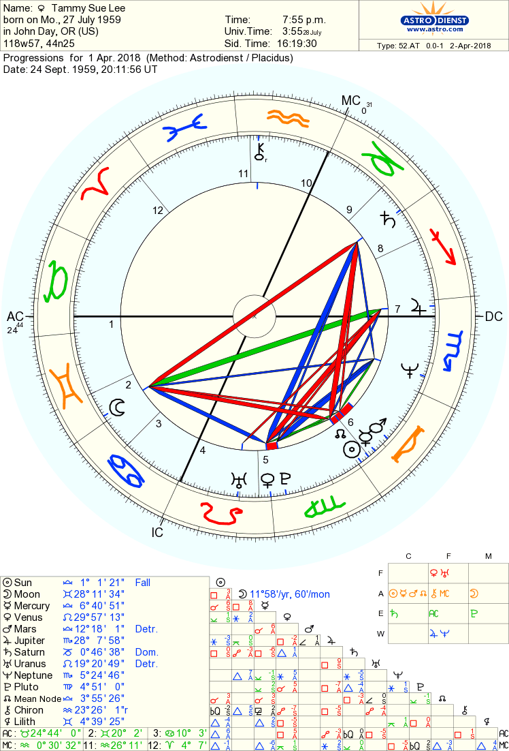

Tammy Sue Lee progressed chart

Note the location of Tammy’s Saturn (Time Lord / Lord of restriction) — Tammy’s time on earth has apparently been “restricted”. And Saturn as Chronos / Grim reaper will bring about her end (God forbid — I want her to stay here and finish out our lives together) will in all probability occur when the tumor inside the top of her spin restricts signals to the body / lungs

Spiculum  
The Lagoon Nebula Eye trouble, blindness, depression, hopelessly doomed, morbid religious outlook, ***no concern for human life***; a nebula in the upper part of the Bow of the Archer. 1° Cap 04 1° Cap 12 Unfortunate Mars/ Moon

Note the T-Square of the Moon (deception, behind the scenes hidden actions), square Saturn and square sun (vitality). The **lack of concern for human life** is described in Charlotte Gerson’s Web post on Medium [LINK](https://medium.com/@heart.beacon.cycle/charlotte-gersons-web-492a1a597993)

I’ve been watching out for the Shaman, Circle of the Sacred Earth’s imagery “I see Sagittarius the Archer and two triangles for years. Saturn the Time Lord is on the cusp of Sagittarius within orb of my fixed star using Sidereal Astrology. The T-Square is a triangle and Capricorn’s / Masonic Goat of Mendez’s head is a triangle. Right again Reverend Kathy ! :)

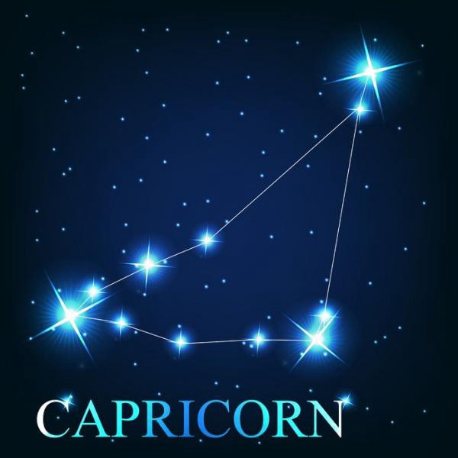A close up of an animal

Description generated with very high confidence

Capricorn The Sea Goat

At 10:13 PM April 2nd 2013 My wife Tammy Sue Lee said:

“please universe, it’s time” (to take me home

At 10:34, I entered Tammy Lee’s birthday into e-tarocchi dot com’s Personal Daily Ancient symbols:

**Your Ancient Symbols for Today:**

[**LINK**](http://e-tarocchi.com/Ancient-Symbols-Daily/) **http://e-tarocchi.com/Ancient-Symbols-Daily/**

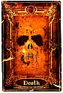<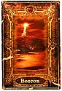

Death is not a card to shy away from. It does not foretell your impending doom. However it does suggest a period of change and the turbulence that often comes with it are on the horizon. We may not always welcome change, but invariably we must change to grow. Sometimes we have to shed some of the comfort of who we are today to embrace the adventure of who we will be tomorrow. Death is the prophecy of such times.

**The Beacon**: The Beacon symbolizes both guidance to safe harbors and a warning of dangerous waters. The Beacon is represented by a lighthouse atop jagged rocks with its powerful light cutting a path that leads to an adjacent entrance to a calm harbor on a stormy night. The Beacon suggest that if you look for it, there is a general path for you to follow to reach a place of peace and harmony. However, The Beacon itself sets upon rough ground, so you must still step carefully as you follow it to quiet waters.

Circa 2006 or so, a woman who visited us as a business development manager for the Turtle Mountain Band of Chippewa Indians visited us in our home. She said that she had zero fear of death because she herself had been pronounced dead on the operating table — twice. She said she came back because she felt she had a mission to do and she would pursue that mission fearlessly. Coincidentally, this is the second time Tammy has been given “the talk” . Speaking of the death card, when the results of Tammy’s birthday and question “staying or going” the death card was [reversed](http://facade.com).



Turtle Mountain Band of Chippewa [LINK](http://tmbci.org/) <http://tmbci.org/>

Coincidentally, Tammy’s mother told her that that when she was born, she looked “like a Turtle”. Tammy’s father was a Coho who was / is a First Nation, Native American. Tammy’s father called her once. I talked to him.

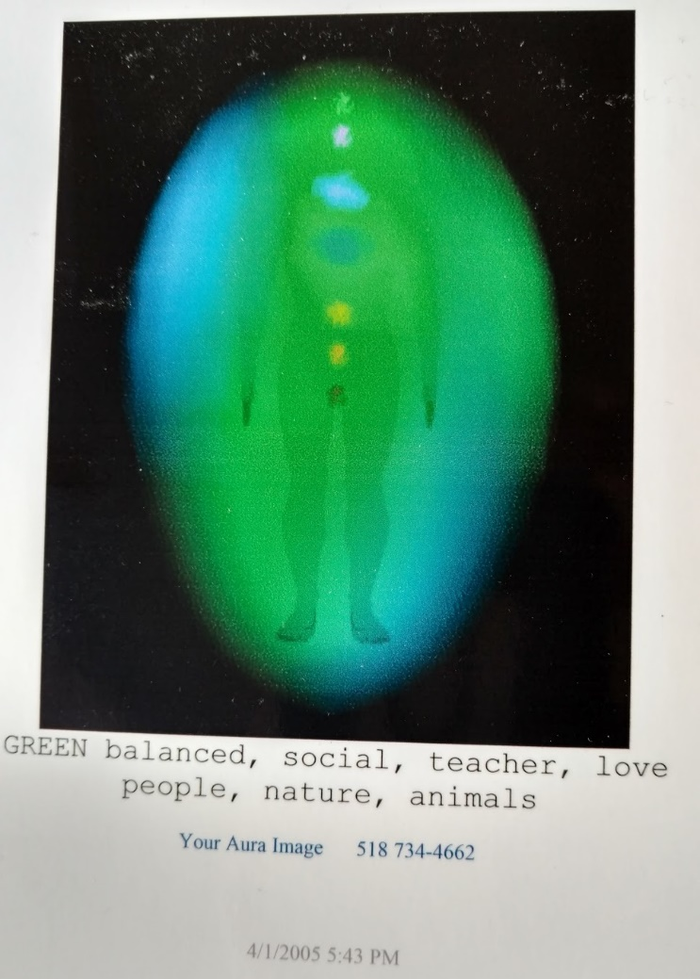

Tammy’s Kirlian Photograph

**Tammy's Kirlian photograph taken April 1st, 2005 as part of a medical intuitive's (Carolyn Myss who wrote the book Sacred Contract’s conference in New York City. The photographer commented that Tammy's heart chakra was twice the size of most other people's...** [**LINK**](https://l.facebook.com/l.php?u=http%3A%2F%2Fwww.crystalinks.com%2Fkirlian.html)[**http://www.crystalinks.com/kirlian.html**](http://www.crystalinks.com/kirlian.html)

Juan, a medical intuitive retired from IBM near Tucson Arizona a.k.a., “Juanbo the Spiritual Rambo” told Tammy that she needed to pull in her auric field so that other people (i.e., me) would not contaminate her. When breast cancer was discovered in Tammy, it’s location was exactly where she would pull my hand to when spooning, snuggling in bed -- coincidentally

April 3rd Update: I entered Tammy’s birthday into e-tariocchi dot com’s web site personal symbols tab and these two symbols were returned. The Heart Beacon Cycle Time — Space meter is intended to support an Eco-Economic pulse to keep the peace and help humanity through a challenging time much the same as the Great Pyramid of Giza when it had crystals etc., operational was said to have broadcasted or magnified the earth’s heartbeat Schumann resonance in order to provide a calming influence during decending Yuga epochs. Reverend Kathy Graves saw me as a little dutch boy (I have Dutch ancestry) holding my finger in the dike.

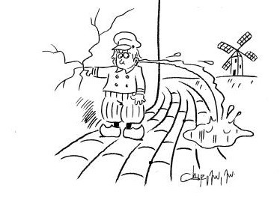

Little Dutch Boy Finger in the Dike

E-tariocchi dot com’s daily ancient symbols, the Peace Dove ancient symbol and the Believer Ancient Symbol were selected on April 3rd coincidentally.

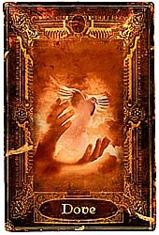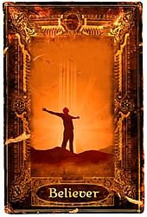

Believer card — that would be me

April 3rd update: my wife Tammy declined my offer to bring her Gerber’s baby food or Gerber breakfast cereal or yogurt etc. She wanted eggs for protein. So, she sent me to one of her standby breakfast choices Dunkin Doughnuts for two egg and cheese breakfast wraps. Being into numerology as a cousin of Astrology and foundation for sacred geometrical metaphysical musings, I noticed that the order number was #672 and the transaction sequence number was 2147672. [LINK](https://www.youtube.com/watch?v=GHyLzZ4wFNI)

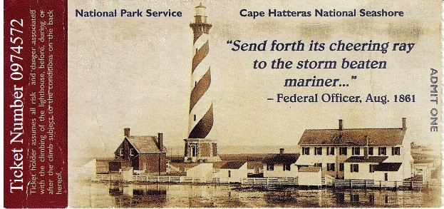

Cape Hatteras Light House Ticket / 30 – 70 Land Use Ordinance

The corporate logo drawn by the Shaman, Circle of the Sacred Earth in the business card below is to be depicted in 3D which makes it a tetrahedron. A pyramid in 3D is a type of tetrahedron that when inverted and two placed opposite of each other fit into a cube, the foundation of all geometric shapes. The objects inside the triangle in the logo were up to me so I selected the outward and inward seeing eye of Providence given the clairaudience “Rhode Island” and the Eagles song and the [Law of Time](https://www.lawoftime.org/pdfs/ch7-intro.pdf) dot org logo given my search on heart, beacon, cycle, time — space and synchronization — and the [cube](https://youtu.be/IwXZV7Ba0HM) of course. The number [72](https://en.wikipedia.org/wiki/Tetragrammaton) is of great significance in the mystery schools as initiates and adepts well know.

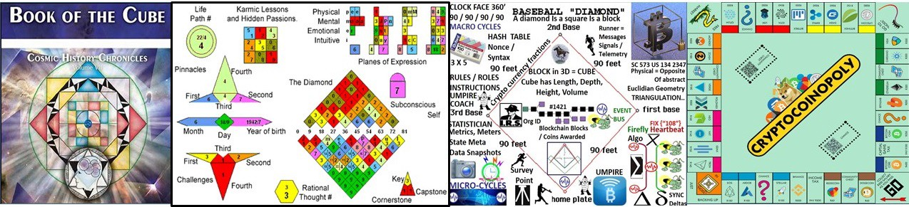

Cube Banner: Book of the Cube — Law of Time / #72 Numerology / Baseball Meme USPTO United States Patent and Trade Mark Office #13/573,002 = 21

1 + 3 + 5 + 7 + 3 + 2 = 21: The World Card

When I was in grades school at Bell Township Elementary going through the motions of playing shortstop, a line drive was hit directly at my chest. Since I was watching the girl’s play kickball instead, the act of my bringing the glove up to my chest at the sound, sight of the ball caused it to tip off the top of my glove into my throat. Minutes of gasping for air later, my adams apple popped out and I could breath again.

During a Reiki session, the Shaman said, I see you playing baseball so I related to her my elementary school tale of almost dying. About a year or two later, the patent attorney I had retained told me that he was no longer accept me as a client unless I explained to him the idea in terms of a Little League Baseball tournament using one graphic shaped like a tree. US Supreme Court’s Alice Corp Vs CLS Bank teaches that “claims may not direct towards abstract ideas”. Physical, like a [baseball diamond](http://www.sawconcepts.com/index/id4.html) is the opposite of abstract. ***Alice Corp. v. CLS Bank International*, 573 U.S. 134 S. Ct. 2347**

Tammy Sue Lee sat with me in the den / computer room the entire week I was working on the patent revision listening to my rants, raves, ruminations. No one else in the world would have had the unconditional love and patience to have done this and put up with me. Tammy Sue Lee, The Heart Beacon has done much to provide a template for the world to follow and mitigate the tough times ahead of mankind. She helped form an modern Great Pyramid of Giza Shuman Heart Beat resonance to help mankind though troubled times.

Cold Play’s [Adventure’s of a Lifetime](https://youtu.be/QtXby3twMmI) “we are diamonds taking shape”

Cape Hatteras Light House protects the Diamond Shoals. Another interesting, coincidental fact about this island is the Shackleford Horses used for DNA genetic drift studies: Video [LINK](https://youtu.be/lFbJP62MdQg) / Web page [link](http://www.wildhorse.com/2000/12/wild-horses-of-shackleford-banks/)

So Tammy’s choice of Memorial Sloan Kettering was made given she wanted to explore advanced clinical trials that she never received. The first chemo Tammy received was derived from bark from a tree. The last chemo she received was finished the year I gradated from college in 1983 and given the go ahead for use in the 1990's… not long after we returned from Europe having met each other in Able Archer 88 — a nuclear release exercise which had a logo looking very much like Woodsy Owl Give a hoot don’t pollute”. Recall Reverend Kathy Graves imagery “I see the Archer (Sagittarius) and two triangles above in the examination of Tammy’s astrological charts.

Able Archer 88 / Rev K “I see the Archer and two triangles”

Speaking of patent application USPTO 13/573,002’s single diagram given the patent attorney located at Eagle Rock New Jersey — another Reverend Kathy Grave’s images which is the reason I found and retained that particular patent attorney in the first place

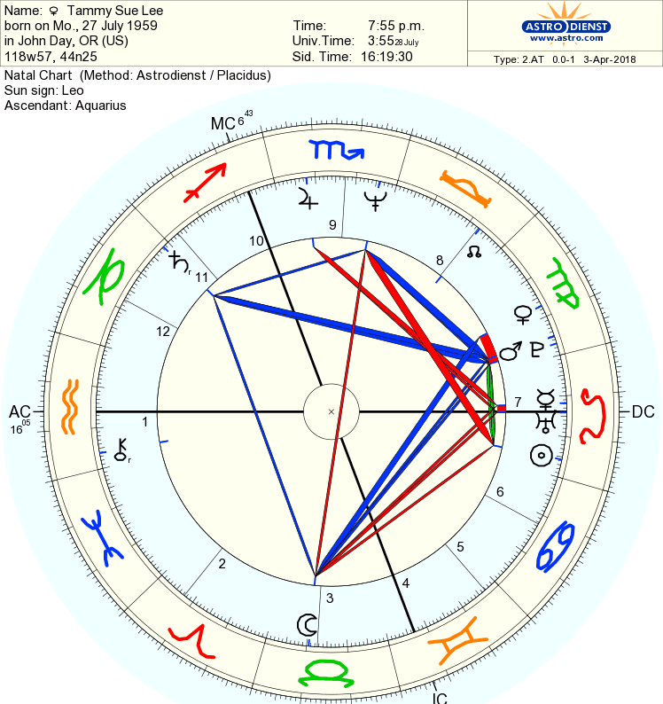

Tammy’s Kite / Shaman’s clairaudience “it’s in the stars”

Greetings Tribe of Light ! On The Galactic Calendar, we now have entered the “The Planetary Moon of Manifestation” (April 4 — May 1)

“This is the time to inquire: What in my life is calling to be manifested? What visions, projects, plans or to-do lists is it time to follow through on and carry out? What in my life is ready to be shifted into a higher creative gear?”

PLEASE ENJOY THE FULL GALACTIC TIME UPDATE HERE: [LINK](https://galacticculture.wordpress.com/2018/04/05/new-galactic-cycle-april-4-may-1-planetary-moon-of-manifestation-time-to-boldly-bring-your-gifts-to-life/)

We Send Blessings to All to of You, From our Hearts to Yours.

May All Beings Be Guided to Serve Love and Serve Life!

In Lak’ech ~ I Am Another Yourself ~

Eden Sky of SkyTime

Activate the Magic of Every Day with The Galactic Calendar!

\*Time to Raise the Frequency on Planet Earth\* <http://13moon.com>

TIME IS ART! LIFE IS ART! LOVE IS ART!

Speaking of Tribes of Light, DNA is though by some to be a receiver for energy / light. See PhD Susan Joy Rennison’s Tuning of the [Diamonds](https://youtu.be/Pmjcs7H7HyU) 72

Dr. Rennison collaborates with Dr. Paul Laviolette’s [Starburst](http://etheric.com/paul-laviolette-bio/) Foundation

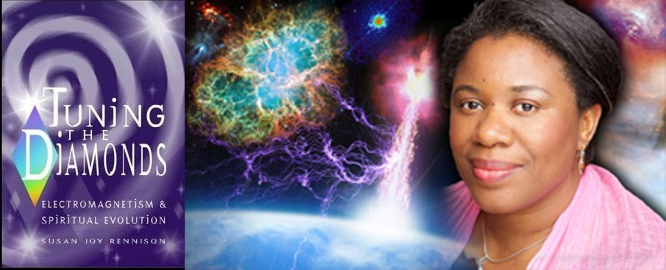

A picture containing ground, sitting, outdoor

Description generated with high confidence

Starburst Foundation [Sphinx](https://youtu.be/B4m7YozDd-8) Stargate

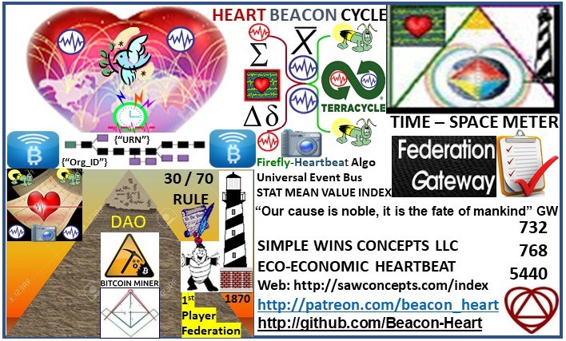

Business Card Logo doodled by Shaman, Circle of the Sacred Earth

**CAPE HATTERAS ISLAND / LIGHTHOUSE THREE MAIN GUIDELINES:**

1**) OBSERVE THE 70 / 30 LAND USE DEVELOPMENT STATUTE = SUSTAINABILITY VS GROWTH. EVERYDAY IS (Spaceship) EARTH DAY** [LINK](http://bit.ly/2onq90G)

**2) OBSERVE THE IMPLIED GUIDANCE OF THE SHACKLEFORD HORSES USED FOR GENETIC DRIFT STUDIES / Wild Horses of Shackleford** [Bank](http://www.wildhorse.com/2000/12/wild-horses-of-shackleford-banks)

**3)**  **FORM AUTONOMOUS, SELF REGULATING GROUPS WITHIN ECO RESPONSIBLE TRADE FEDERATIONS SUPPORTING OUR SPACESHIP EARTH'S ECO SYSTEM / BIOSPHERE**

A picture containing text

Description generated with very high confidence

**A close up of a womans face

Description generated with high confidence**

Speaking of Genetics, cycles of catastrophe and the evolution of mankind facilitated by energy passing through the earth, crystals, diamonds…

Synopsis of Book For millennia the best minds of humanity have sought to answer the questions: 1) What Are We? 2) Why Are We Here? Tuning the Diamonds Electromagnetism & Spiritual Evolution unites these two vastly different areas of human endeavor with a brilliance that will illuminate and most importantly satisfy both sides that strive to achieve this endeavor. Ask anyone and they will tell you that ...something s going on. Some believe we are in the "End Times", others say there's a galactic alignment taking place. There are some who suggest a government conspiracy and others are convinced that an alien invasion is imminent. Whatever tale is told, the stresses upon humanity - infact all living organisms and upon our very solar system - have never been greater.

Tammy gave me a copy of Carolyn Myss’s Book Sacred Contracts about ten years ago coincidentally. Carolyn Myss works with another medical intuitive woman with two PhD’s who was diagnosed to be bipolar coincidentally.

A close up of text on a white surface

Description generated with very high confidence

Tammy’s gift to me ten or more years ago

My take on all of this is that given Tammy’s astrological birth chart features a kite formation, Tammy will soar up out of these mortal coils having volunteered as part her (Carolyn Myss) [Sacred](https://www.goodreads.com/book/show/190115.Sacred_Contracts) contract to be with her ancestors (I’ve been drawing the Ancestor Ancient symbol card alot)… …

A picture containing indoor, photo, wall

Description generated with high confidence

where she will watch the chaos and confusion down below humming the MC Hammer [Song](https://youtu.be/z5X5zh00rdg) “can’t touch this”…

Lyrics:

You can’t touch this  
You can’t touch this  
You can’t touch this  
You can’t touch this

My, my, my my music hits me so hard  
Makes me say, “Oh my Lord”  
Thank you for blessin’ me  
With a mind to rhyme and two hype feet  
It feels good, when you know you’re down  
A super dope homeboy from the Oaktown  
And I’m known as such  
And this is a beat, uh, you can’t touch

I told you homeboy (You can’t touch this)  
Yeah, that’s how we livin’ and ya know (You can’t touch this)  
Look in my eyes, man (You can’t touch this)  
Yo, let me bust the funky lyrics (You can’t touch this)

Fresh new kicks, and pants  
You gotta like that, now you know you wanna dance  
So move outta yo seat  
And get a fly girl and catch this beat  
While it’s rollin’, hold on!  
Pump a little bit and let ’em know it’s goin’ on  
Like that, like that  
Cold on a mission, so fall on back  
Let ’em know, that you’re too much  
And this is a beat, uh, they can’t touch

Yo, I told you (you can’t touch this)  
Why you standin’ there, man? (You can’t touch this)  
Yo, sound the bell, school’s in, sucka (You can’t touch this)

Give me a song, or rhythm  
Makin’ ’em sweat, that’s what I’m givin’ ‘em  
Now, they know  
You talkin’ ‘bout the Hammer, you’re talkin’ ‘bout a show  
That’s hyped, and tight  
Singers are sweatin’, so pass them a wipe  
Or a tape, to learn  
What’s it gonna take in the 90’s to burn  
The charts? Legit  
Either work hard or you might as well quit

That’s word because you know (You can’t touch this)  
(You can’t touch this)  
Break it down!

Stop, Hammer time!

Go with the flow, it is said  
That if you can’t groove to this then you probably are dead  
So wave yo hands in the air  
Bust a few moves, run your fingers through your hair  
This is it, for a winner  
Dance to this and you’re gonna get thinner  
Move, slide your rump  
Just for a minute let’s all do the bump  
(Bump, bump, bump)

Yeah (You can’t touch this)  
Look, man (You can’t touch this)  
You better get hype, boy, ’cause you know you can’t (You can’t touch this)  
Ring the bell, school’s back in  
Break it down!

Stop, Hammer time!

You can’t touch this  
You can’t touch this  
You can’t touch this  
Break it down!

Stop, Hammer time!

Every time you see me, the Hammer’s just so hyped  
I’m dope on the floor and I’m magic on the mic  
Now why would I ever stop doin’ this?  
With others makin’ records that just don’t hit  
I’ve toured around the world, from London to the Bay  
It’s “Hammer, go Hammer, MC Hammer, yo Hammer”  
And the rest can go and play  
You can’t touch this

You can’t touch this  
You can’t touch this  
Yeah (You can’t touch this)  
I told you (Can’t touch this)  
Too hot (Can’t touch this)  
Yo, we outta here (Can’t touch this)

Songwriters: ALONZO MILLER, RICK JAMES, STANLEY KIRK BURRELL© Sony/ATV Music Publishing LLC

At 03:15 AM April 6th, 2018, Tammy Sue Lee is on oxygen sleeping. I just gave her several sips of water. She has her hand over her heart and is comforting herself by very softly patting herself over her heart.



Tammy Lee McGee’s Facebook banner

Toes in the sand Tammy Lee, Toes in the sands…

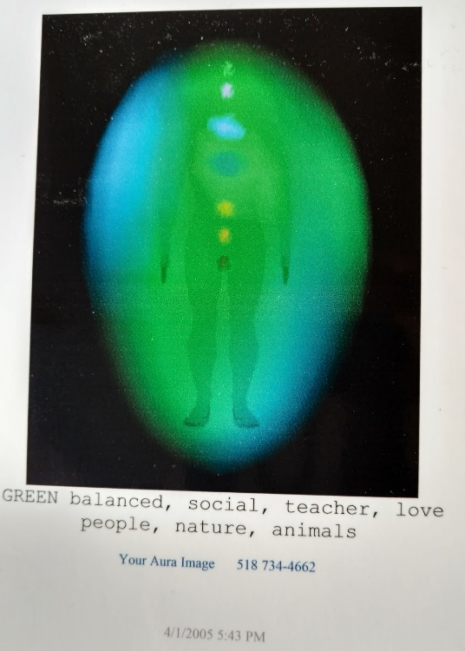

God’s speed Tammer the Hammer ! It’s HAMMER TIME !

Go with Spirit Tammy Sue Lee if that is your will. If you plan on staying here a while longer I will be overjoyed. If you decide to rejoin your ancestors for another great adventure, so be it. We all know you will be untouchable above the clouds flying high as kites can possibly fly.

**A picture containing person, indoor, sitting, clothing

Description generated with high confidenceA close up of a device

Description generated with high confidence**

[Tammy Lee McGee](https://www.facebook.com/tammyleemcgee?hc_ref=ART4ROPZk0EJ1AbXpZeuH-fmcX0ASrRIoaf-q80Rsrvdz4UWUyINbKX2UolmksBN4Wg&fref=nf) FACEBOOK ENTRY [April 17, 2013](https://www.facebook.com/photo.php?fbid=474158915989382&set=a.288749484530327.66746.100001858322363&type=3)

You must have been a beautiful baby! Happy Birthday, Earth Angel!

Thank you from the bottom of my little heart. Thank you Tammy Sue Lee. You will always be my guardian angel and my light from above. Bless you for your heart chakra that is twice the size of most people’s.. see the light shining down from above and the halo? You are an old soul who took the most difficult of assignments altruistically. Thank you for all your life lessons, infinite patience, compassion, and unconditional love Tammy Sue Lee.

ADDENDUM: 14 April 2018

April 10th 15:30 PM Tammy took another drink of liquid with me holding the cup.  Her hands are clasped behind her head again.. sort of awake... exhausted...  water tank replacement is here from Eatontown TV and Appliance.  When he looked at the tank, he said "this is weird, the tank exploded from the top instead of the bottom" – I’ve never seen this happen like this before.

Healers / energy medicine practitioners cite emotions as triggers / contributing factors for **dis**-ease (disease).   
  
Coincidentally,  while the visiting nurse and the social worker were checking on Tammy for what would be the last time and citing that Tammy was "peaking" "peeping" (think of peek a boo without seeing) during the late morning the day of Tammy's passing, the hot water tank was arriving for replacement.  The hot water tank installer remarked that he never saw a hot water tank explode up and out from the tank from the top before....

A picture containing sky, outdoor, grass, mammal

Description generated with very high confidenceA picture containing indoor, table, computer, desk

Description generated with very high confidence

Yellowstone National Park / Heart Lake / Water heater top explosion

A close up of text on a white background

Description generated with high confidence

Mother Shipton / Rev K: “I see a huge buffalo staring down General Custer”

Yet greater sign there be to see; As man nears latter century. Three sleeping mountains gather breath, And spew out mud, ice and death. An earthquake swallow town and town; In lands as yet to me unknown. And Christian one fights Christian two And nations sigh, yet nothing do. And yellow men great power gain; From a mighty bear with whom they’ve lain. {Volcanoes, earthquakes (in unknown land - America?)

[LINK:](http://www.bibliotecapleyades.net/esp_shipton01.htm) http://www.bibliotecapleyades.net/esp\_shipton01.htm

April 13th 2018: meeting Tammy's brother Vern in the Double Tree Hotel lobby, Vern heard on the news that the whales were migrating south early this year. Coincidentally, I’ve been posting my fishing dream for years

A screenshot of a cell phone screen with text

Description generated with high confidence

A group of people posing for the camera

Description generated with very high confidence

Fisherman tells us to look to the south east (towards Aruba where Tammy wanted to go because it’s an arid island in the middle of the Atlantic to see a whale spouting – the whales are migrating early this year coincidentally   
  
On the trip to Richmond on Highway 301, I saw a Hammer Transport truck and a Beacon truck.  Stopping at a gas station, I saw a Reliable Energy Management Truck (see Chi / Prana / Kirlian photographs)

A close up of text on a black background

Description generated with very high confidence  
**Georgia Guide Stones / America’s Stonehenge**

**Georgia Guidestone’s** [**CUBE**](https://www.youtube.com/watch?time_continue=8&v=rpk5hdHrpoY)· Geolocation 34.23232° N, -82.89438° E

### Inscriptions[: A message consisting of a set of ten guidelines or principles is engraved on the Georgia Guidestones[[8]](https://en.wikipedia.org/wiki/Georgia_Guidestones" \l "cite_note-Smithsonian-8) in eight different languages, one language on each face of the four large upright stones. Moving clockwise around the structure from due north, these languages are: [English](https://en.wikipedia.org/wiki/English_language), [Spanish](https://en.wikipedia.org/wiki/Spanish_language), [Swahili](https://en.wikipedia.org/wiki/Swahili_language), [Hindi](https://en.wikipedia.org/wiki/Hindi), [Hebrew](https://en.wikipedia.org/wiki/Hebrew_language), [Arabic](https://en.wikipedia.org/wiki/Arabic_language), [Chinese](https://en.wikipedia.org/wiki/Chinese_language), and [Russian](https://en.wikipedia.org/wiki/Russian_language).

1. Maintain humanity under 500,000,000 in perpetual balance with nature.
2. Guide reproduction wisely — improving fitness and diversity.
3. Unite humanity with a living new language.
4. Rule passion — faith — tradition — and all things with tempered reason.
5. Protect people and nations with fair laws and just courts.
6. Let all nations rule internally resolving external disputes in a world court.
7. Avoid petty laws and useless officials.
8. Balance personal rights with social duties.
9. Prize truth — beauty — love — seeking harmony with the infinite.
10. Be not a cancer on the earth — Leave room for nature — Leave room for nature.

****

**One thing Tammy and I shared in common despite being opposites on the Zodiac wheel and in life is that we both ran high school cross country. Tonight I repeated the affirmation I have made to honor Tammy’s profound Sacred Contract. On the morning after her passing, her Oncologist Dr. Susan Greenberg called and said "no matter how much trash was dropped down on her head, she just kept on smiling that sweet little smile". I responded automatically as if the words were not my own "Tammy accomplished what she had come here to do".**

**A close up of text on a white surface

Description generated with very high confidence**

**Tonight, a little voice told me that I needed to play the Coldplay song "Paradise". This song led me to another more poignant song "Miracles" by Coldplay. The video includes scenes from the movie "Unbroken" that we watched together. Miracles by Coldplay begins with these words: "I've made it this far and refused to give up because all my life I had always finished the race". Quote by Louis Zamperini. Coincidentally, I had reposted this montage from the movie Toy Story 3 recently (see attached) / MIRACLES – UNBROKEN by Coldplay** [**LINK**](https://youtu.be/7atDQreame4)

**A picture containing photo

Description generated with very high confidence**

**Toy Story III collage posted to my social media pages**

**April 15th 03:25 AM 2018:**

**Last entry from the "last, least among you" / scribe / husband / friend** [**LINK**](https://www.caringbridge.org/visit/tammymcgee/journal)

**Tarot cards are a fascination of mine and being in denial and confused because Tammy had begun "peeping, peaking" yet she was still (autonomic-ally) drinking water, I performed a Tarot reading. I carefully choose a card asking to be given the truth of the situation (I'm an Aquarius, Aquarius Rising Truth seeker). I carefully passed my hands slowly over the cards asking to be guided to the card that would reveal the truth. Additionally, Facade dot com does reversals so I actually did two readings. I drew the Death card. However, the card was reversed. Further the card was paired with the ten of swords in these readings. Dr. Susan Greenberg called the following morning (see prior reading) and asked if she was in pain. I said that I did not think so because of the cluster of lesions the X-rays revealed at the top of the spine with a lesion inside the spinal column that was "inoperable". This lesion was shielded by bone and protected by the sealed off nature of the spinal fluid.**

**A picture containing text

Description generated with very high confidence**

**Reversed Death Tarot Card Meanings. Death is a card of transformation and new life, and typically shows a need to start completely over by letting go of the past. Death reversed typically reflects that you are on the verge of major change but for some reason, you are resisting making that change. Aeclectic Tarot** [**LINK**](http://www.aeclectic.net/tarot/learn/meanings/ten-of-swords.shtml)

**Aeclectic Tarot: Ah, the Death Card. Signifies an end to something, a time of grieving with the hint that there will be something new to take the place of this lost thing in the future. Rebirth is at the other end of this tunnel, but a dark tunnel must be traversed. Reversed?**

**1) Opposite: Sometimes, things need to come to a blessed end. Anyone who's had someone in the hospital, alive but not alive, holding to life but not living, knows that "not death" isn't a desired thing. Not death keeps people from grieving, and from starting over again when done. It just stretches out a "not-life."**

**2) Death Reversed:** [**LINK**](LINK) **http://www.aeclectic.net/tarot/card-meanings/reversed/death.shtml**

**A close up of a logo

Description generated with high confidence**

**Ten of Swords: When the 10 appears, however, it is a clear signal to be careful about where you put your trust. Linda "The Psychic" Shields "Trust no one"**

**Ten of swords: rock bottom, finished, give up, closure. When the 10 of swords appears in the reading it is likely that the situation has become as bad as it possibly can. Enough is enough. There is nowhere to go but up. A person has made huge sacrifices for others and received little to nothing in return. Pick yourself up and get on with life. Take the lessons you’ve learned (that would be me because Tammy was my greatest teacher, especially during her final months) with you so you don’t make the same mistakes again.**

[[](https://www.thejerseyshoremedium.com/)](https://www.thejerseyshoremedium.com/" \t "_self)

**"I am simply a lady doing what I can to help as many people as possible to find peace, understanding, and often times closure!"**

**Linda The Psychic The Jersey Shore Medium:** [**https://www.thejerseyshoremedium.com**](https://www.thejerseyshoremedium.com)

**Tammy called me circa early 2000’s to ask if I wanted a session with Linda “The Psychic” Shields based on a last minute cancellation at a friend’s Tupperware / Psychic reading with pizza party. Knowing that Tammy’s mother Kathy often saw a Shaman name Juan whom I called “Juanbo the spiritual Rambo” (who retired from IBM). I said that I would be right over. Linda the Psychic spent the session lecturing me about method patents after she said “what are you doing to protect your ideas”. It took me two years to figure out what I was “painting a different color” – Blue Force Tracker Communication Electronic’s Command’s “Greatest Invention” commercial grey.After Linda “The Psychic” had launched me on my decade plus long vision quest that no one other than Tammy would put up with as a wife, Tammy vectored me to a Chiropractor’s office where Revered Kathy Graves was offering 30 minute Reiki sessions. Reverend K asked me it I wanted her to “deliver the mail” and that I had a lot of mail in the queue. Tammy’s sacrifice “gave birth” to the Heart Beacon Cycle: Sacred Contracts: Awakening Your Divine Potential by medical intuitive Carolyn Myss** [**LINK**](https://www.goodreads.com/book/show/190115.Sacred_Contracts)

**Sacred Contracts:** [**https://www.goodreads.com/book/show/190115.Sacred\_Contracts**](https://www.goodreads.com/book/show/190115.Sacred_Contracts)

Coincidentally, my birth chart has a Yod February 10th 1960 @ 06:44 AM Yod in Astrology - A Karmic Pattern - AstroManda www.astromanda.com/yod-in-astrology-a-karmic-pattern Yod is an astrological aspect that has 2 quincunx (150 degrees) and 1 sextile (60 degrees) forming a narrow triangle. It is also called the “Finger of God”. Quincunx is an aspect between 2 planets that are not quite compatible in any way so the only manner they can work together is by adjusting and accepting. Juanbo "The Spiritual Rambo" -- say these words "accept, adjust, allow" [LINK](http://www.astromanda.com/yod-in-astrology-a-karmic-pattern/)

**A person standing in a room

Description generated with high confidence**

**YOD in Tammy’s husband Steve’s Astrological Chart**

**The point of all of this is to showcase the power of the HEART**

**A picture containing clipart

Description generated with very high confidence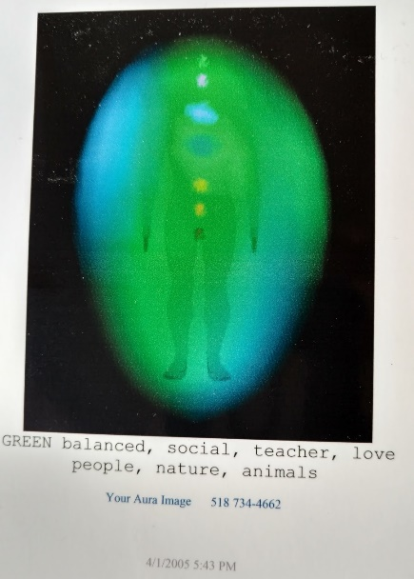**

**Tammer The Hammer the Heart Beacon**

**A close up of a logo

Description generated with high confidence**

**At the time of this posting, I am in Richmond Virginia - Midlothian https://en.wikipedia.org/wiki/Midlothian\_High\_School\_(Virginia) known for the French Huguenauts - Wikipedia** [**https://en.wikipedia.org/wiki/Huguenots**](https://en.wikipedia.org/wiki/Huguenots)**.**

**A little voice told me that I am to post Tammy's "Dream" wall on the wall in our Master Bedroom. I am also to post to this site and the Microsoft Word Tribute I wrote, the** **First Nation Native American Indian Chief print who looks like he's wrapped up in a Wigwam that has a Buffalo in the lower right hand corner.**

**A close up of a sign

Description generated with high confidence**

During Tammy's final hours and final few days, the water heater blew up and out of the top instead of the normal bottom of the water heater. While she was passing in the morning while the nurse and the social worker were still there (mentioning that Tammy was "peeping" / peeking as in the game hide and go seek), the installation technician arrived with the replacement heater. He remarked that the old water heater exploded upwards -- something he's never seen before... coincidentally....

**See the last** [**entry**](https://www.caringbridge.org/visit/tammymcgee/journal) **Coldplay' Miracle video. Tammy and I also grew up with railroad tracks in our back yards. Tammy left this world next to a set of railroad tracks running north / south -- like the dogsleds were running in Reverend Kathy Grave's images during one of our earliest sessions -- see magnetic pole reversals (Tammy being the heart and me the Beacon)**

**A small blue bird perched on a branch

Description generated with very high confidence**

**April 20th, while walking and thinking about what memorabilia to keep, what I brought down to Richmond for safe keeping (the Blue Bird picture Tammy kept as a keep sake of her Mother Kathy) a blue bird landed In the tree near us. I’ve never seen a Blue Bird in the wild before coincidentally. Hi Tammy’s mom Kathy Lee ! Thank you for introducing me to Shamanism**

**A picture containing indoor, wall

Description generated with very high confidence**

**Tammy’s DREAM wall presentation from our Master Bedroom**

**A picture containing text, book

Description generated with very high confidence**

**First Nation Indian Chief print. Note the Buffalo in the lower right hand corner. Tammy grew up by railroad tracks near Hotel Benson that hosted many famous Wild West luminaries. Tammy transcended her chosen Earth School Sacred Contract by a set of railroad tracks leading to NYC “center of the Universe” Note the railroad track wheels on the fireplace mantle. Note the salt lamp / T’s salt urn.**

**A fire place sitting in a living room with a fireplace

Description generated with high confidence**

**Our living room: First Nation Chief / Buffalo / Railroad wheels / salt light / salt urn**